OBJECTIVE:
- Implement I/O Port interface and calculation instructions.

REFERENCES:
- Lab Manual Chapter 1-2

EXPERIMENT 1:
- Connect one AVR port (e.g., PORT A) to a dip switch. Connect another port to a LED bar (e.g., PORT B).
- Write a program to continuously read the state of the dip switch and send it to the LED. If the switch is in the OFF state, the corresponding LED will turn off.

EXPERIMENT 2:
- Write a program to read the value of the port connected to the dip switch, add 5 to it, and send it to the port connected to the LED bar.
- Change the state of the dip switch and observe the status of the LED bar.

EXPERIMENT 3:
- Connect and implement a program to calculate the product of two nibbles (high and low) of PORT A and send it to PORT B. Consider these two nibbles as unsigned numbers.
Example: PORT A = 0b0111_1111, then PORT B = 3 * 15.
- Change the state of the dip switch and observe the status of the LED bar.

EXPERIMENT 4:
- Connect and implement a program to calculate the product of two nibbles (high and low) of PORT A and send it to PORT B. Consider these two nibbles as signed numbers.
Example: PORT A = 0b0111_1111, then PORT B = 3 * (-1).
- Change the state of the dip switch and observe the status of the LED bar.

EXPERIMENT 5:
- Connect PA0 to a single switch and PA1 to a single LED on the LED block (note that they are from the same port).
- Write a program to turn on the LED if the switch is pressed and turn it off if the switch is released.

EXPERIMENT 1
- Answer the following questions:
  - How do you retrieve values from the two nibbles of PORT A?
- Use the “IN” instruction to copy those values into a register.
  - How do you enable pull-up resistors?
- Set PORTX to high by add 0xFF to them.
  - When the switch is in the ON/OFF state, what is the pin value of the port?
- If the pull-up resistors are enabled, pin will get 1 at OFF state and 0 at ON state (of the switch).
  - When the port pin is in state 1, is the BAR LED on or off?
- Pin is in state 1 so BAR LED is on.
  - Source code with comments.
START:
LDI R17, $00 ;LOAD R17 = 00
LDI R16, $FF ;LOAD R16 = FF
OUT DDRB, R16 ;SET DDRD = 1 --> OUTPUT

OUT DDRA, R17 ;SET DDRB = 0 --> INPUT
OUT PORTA, R16 ;SET PULL UP REGISTER AT PORTA
READ_PIN:
IN R18, PINA ;READ INPUT VALUE FROM PINA TO R18

OUT PORTB, R18 ;LOAD VALUE OF R18 TO PORTB
RJMP READ_PIN ;READ AGAIN

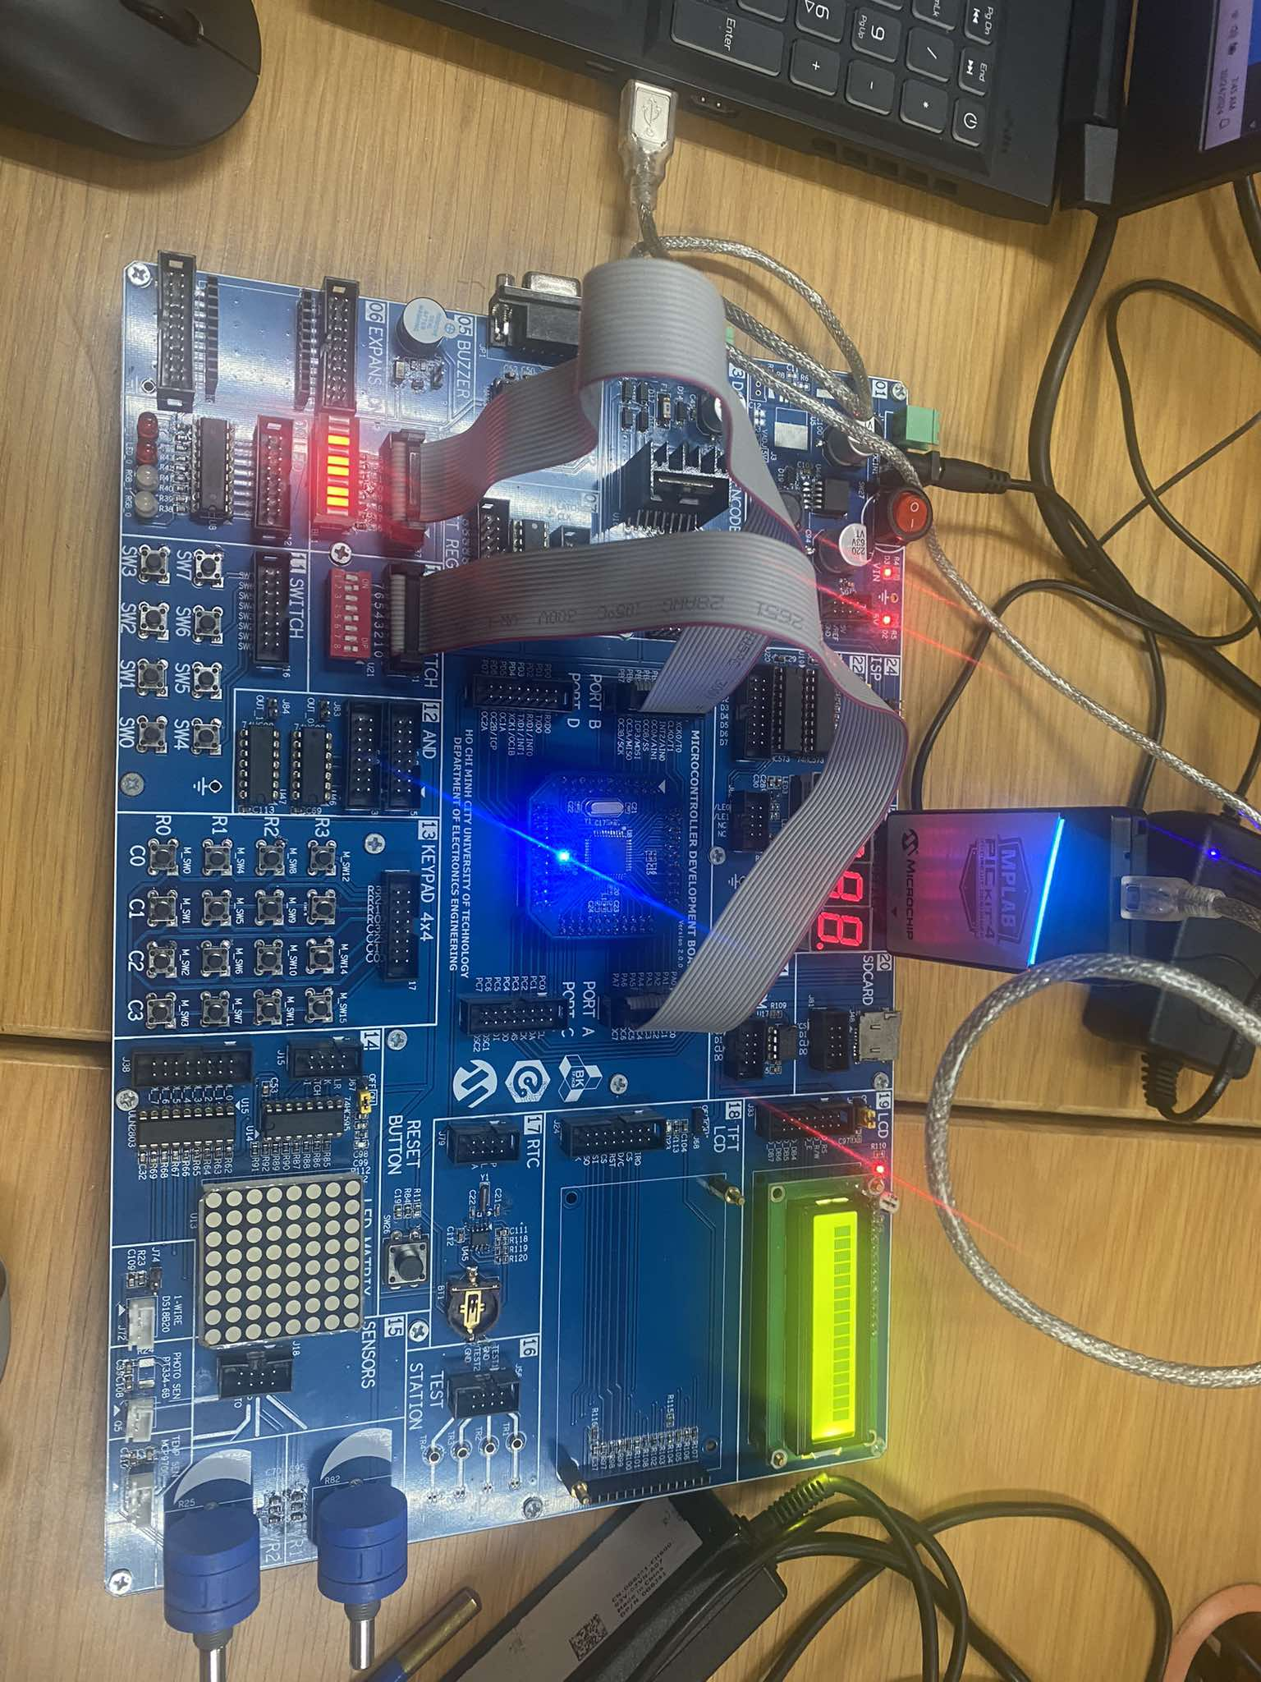

EXPERIMENT 2
- Answer the following questions:
  - Source code with comments.
START:
LDI R19, $05 ;LOAD R19 = 5
LDI R17, $00 ;LOAD R17 = 00
LDI R16, $FF ;LOAD R16 = FF
OUT DDRB, R16 ;SET DDRD = 1 --> OUTPUT
;
OUT DDRA, R17 ;SET DDRB = 0 --> INPUT
OUT PORTA, R16 ;SET PULL UP REGISTER AT PORTA
READ_PIN:
IN R18, PINA ;READ INPUT VALUE FROM PINA TO R18
LDI R20, 0x05 ;LOAD 5 TO R20
ADD R18, R20 ;ADD 5 TO R18
OUT PORTB, R18 ;LOAD VALUE OF R18 TO PORTB
RJMP READ_PIN ;READ AGAIN

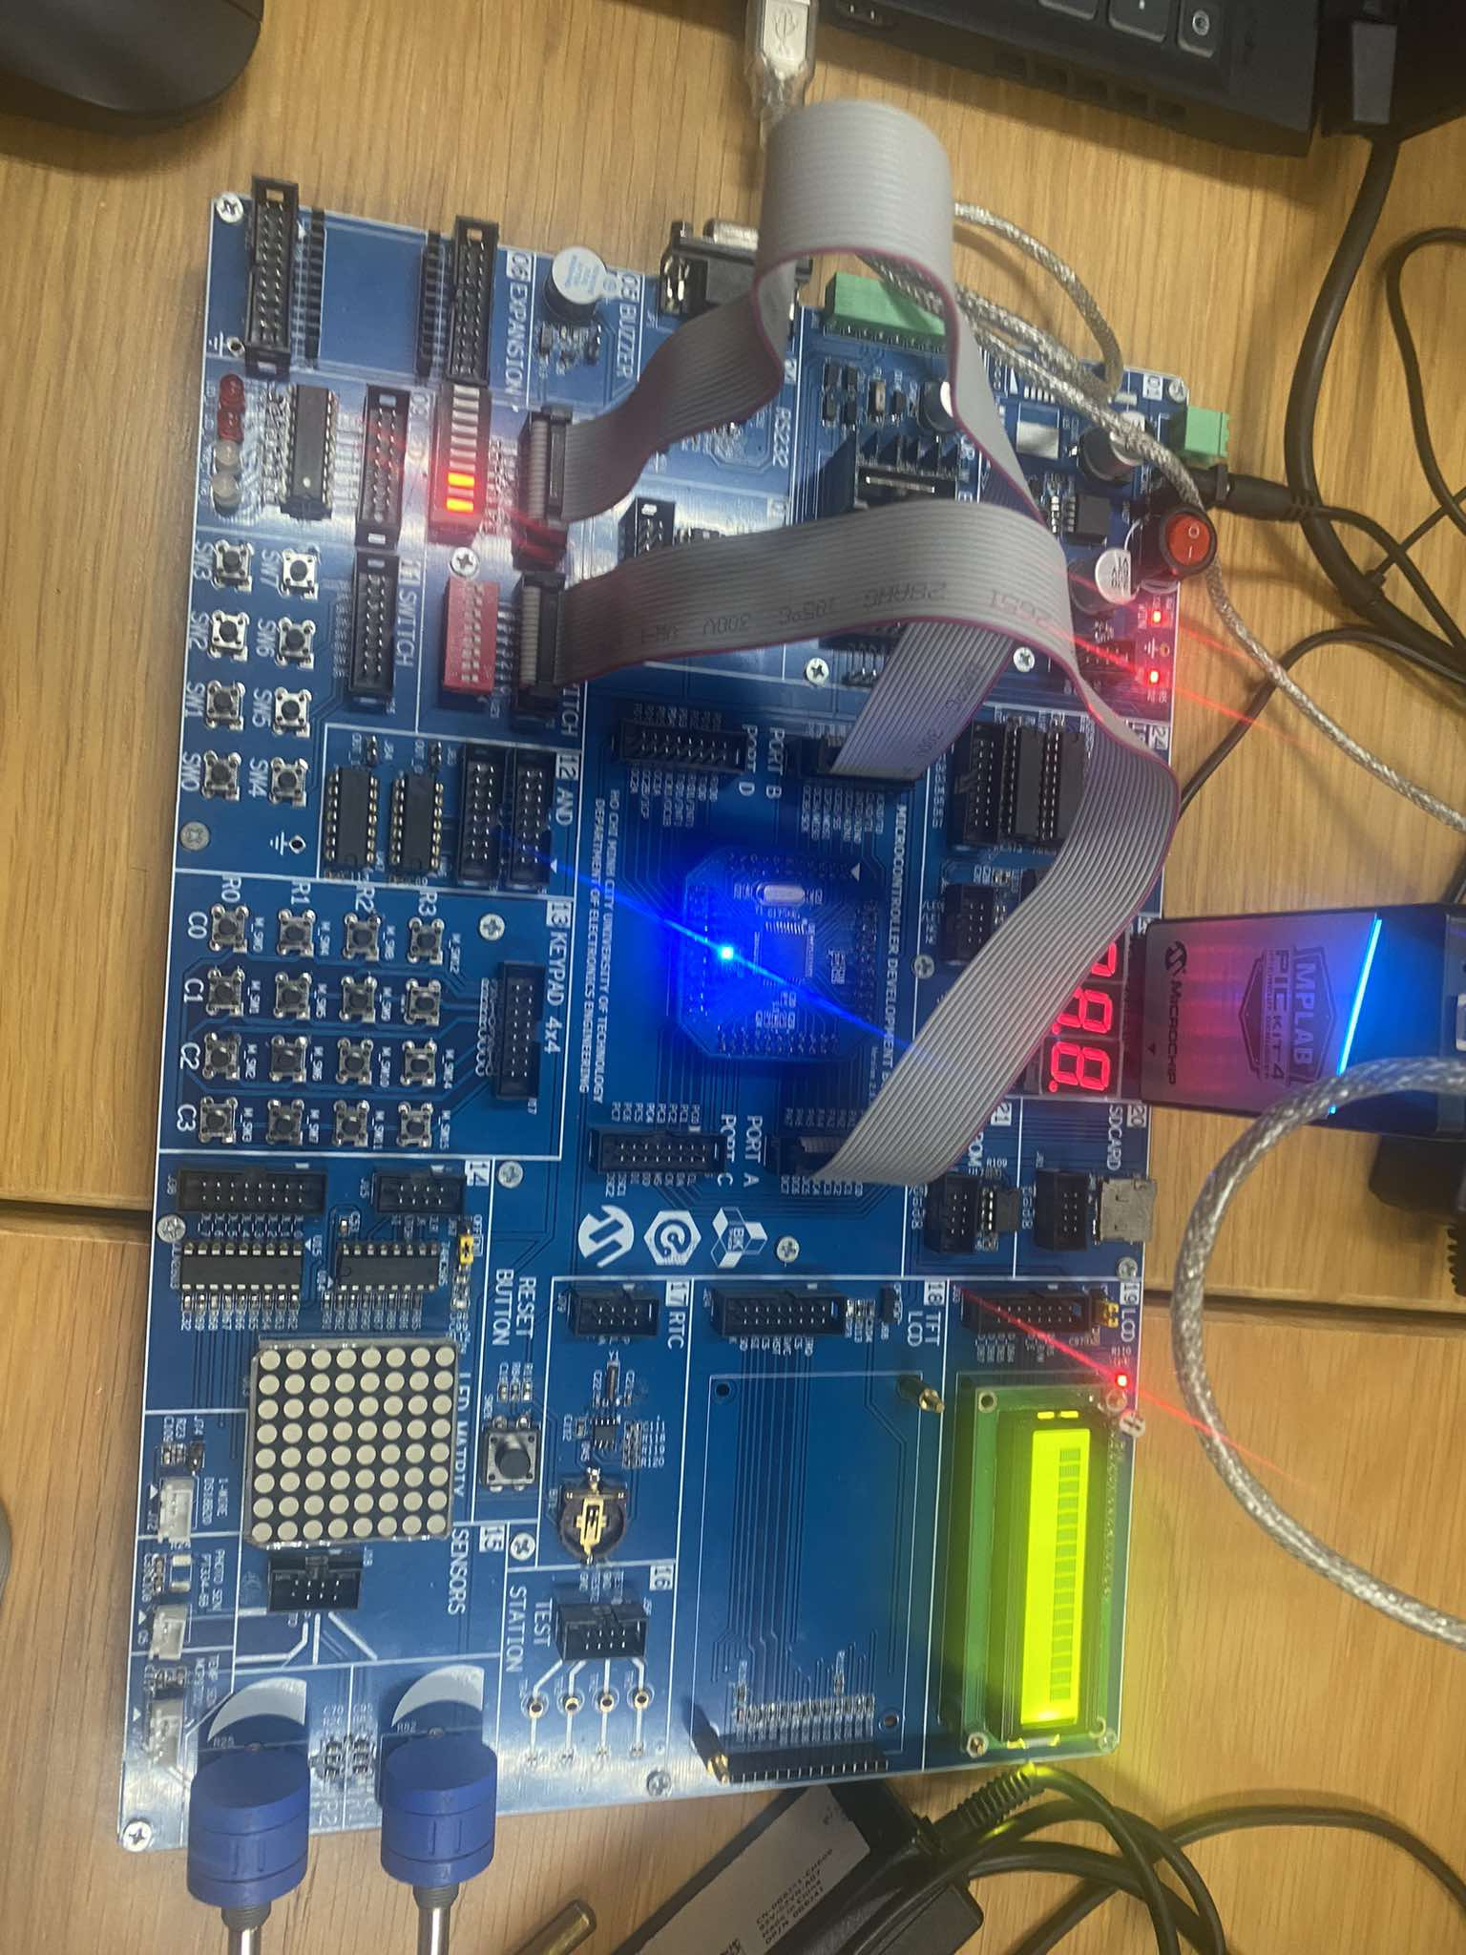

EXPERIMENT 3
- Answer the following questions:
  - How do you retrieve values from the two nibbles of PORT A?
- First, we get low nibble by doing logic AND 0F with value in PORTA and store them to a register. Second, use SWAP to change the high nibble back and do logic AND 0F with the swapped value and store to another register. Now we have 2 nibbles.
  - Source code with comments.
START:
LDI R17, $00 ;LOAD R16 = 00
LDI R16, $FF ;LOAD R16 = FF
OUT DDRB, R16 ;SET DDRB = 1 --> OUTPUT
;
OUT DDRA, R17 ;SET DDRA = 0 --> INPUT
OUT PORTA, R16 ;SET PULL UP REGISTER AT PORTA
READ_PIN:
IN R18, PINA ;READ INPUT VALUE FROM PINA TO R18
ANDI R18, $0F ;AND R18 WITH 00001111 TO GET LOW NIBBLE
IN R19, PINA ;READ INPUT VALUE FROM PINA TO R19
SWAP R19 ;SWAP NIBBLES TO CHANGE THE HIGH NIBBLE TO LOW NIBBLE
ANDI R19, $0F ;AND R19 WITH 00001111 TO GET THE HIGH NIBBLE AS WE DID THE SWAP
CALL MULTIPLY ;DO MULTIPLICATION
RJMP READ_PIN ;TURN BACK TO CHECK INPUT
MULTIPLY:
MUL R18, R19 ;DO MULTIPLICATION, RESULT WILL BE STORE IN R0
OUT PORTB, R0 ;LOAD THE RESULT TO PORTB, USE R0 AS THIS STORE THE LOW BITS
RET
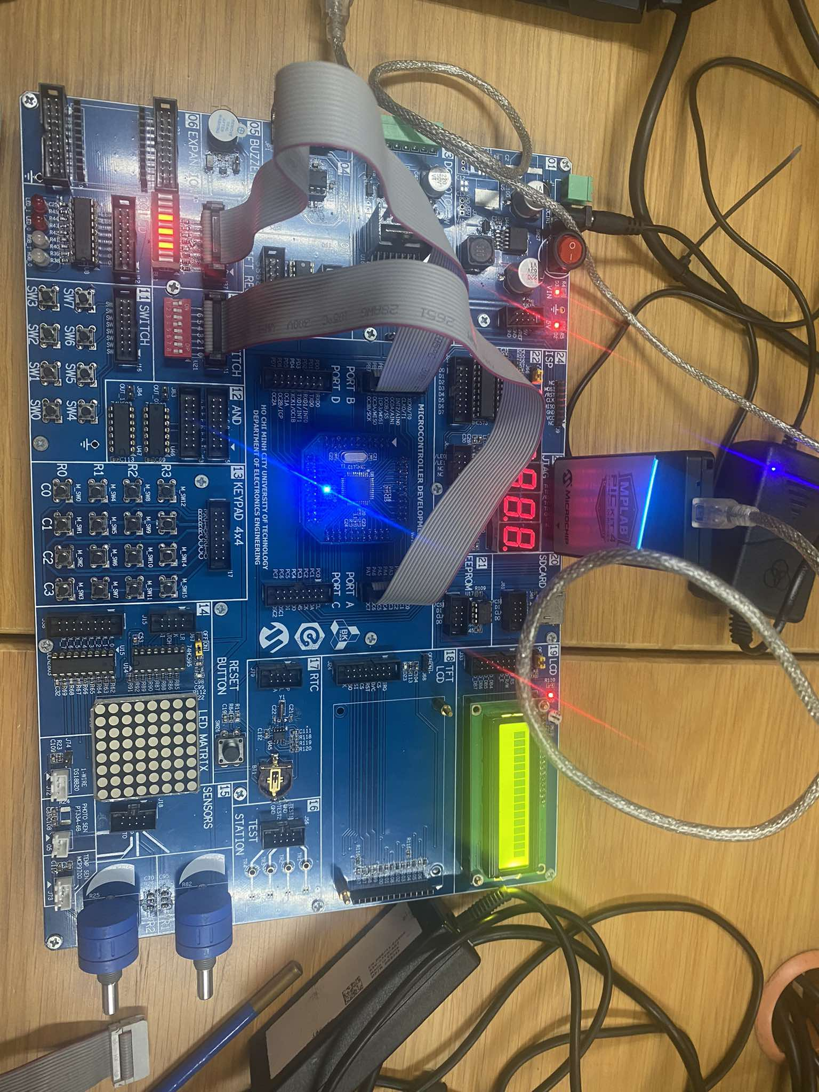

EXPERIMENT 4
- Answer the following questions:
  - Source code with comments.
START:
LDI R16, $FF ;LOAD R16 = FF
OUT DDRB, R16 ;SET DDRB = 1 --> OUTPUT
;
LDI R17, $00 ;LOAD R17 = 00
OUT DDRA, R17 ;SET DDRA = 0 --> INPUT
;
OUT PORTA, R16 ;SET PULL UP REGISTER AT PORTA
READ_PIN:
IN R18, PINA ;READ INPUT VALUE FROM PINA TO R18
ANDI R18, $F0 ;AND R18 WITH 00001111 TO GET HIGH NIBBLE
IN R19, PINA ;READ INPUT VALUE FROM PINA TO R19
SWAP R19 ;SWAP NIBBLES TO CHANGE THE HIGH NIBBLE TO LOW NIBBLE
ANDI R19, $F0 ;AND R19 WITH 00001111 TO GET THE LOW NIBBLE AS WE DID THE SWAP
CALL MULTIPLY ;DO MULTIPLICATION
RJMP READ_PIN ;TURN BACK TO CHECK INPUT
MULTIPLY:
MULS R18, R19 ;DO MULTIPLICATION, RESULT WILL BE STORE IN R0
OUT PORTB, R1 ;LOAD THE RESULT TO PORTB, USE R1 AS THIS STORE THE HIGH BITS
RET
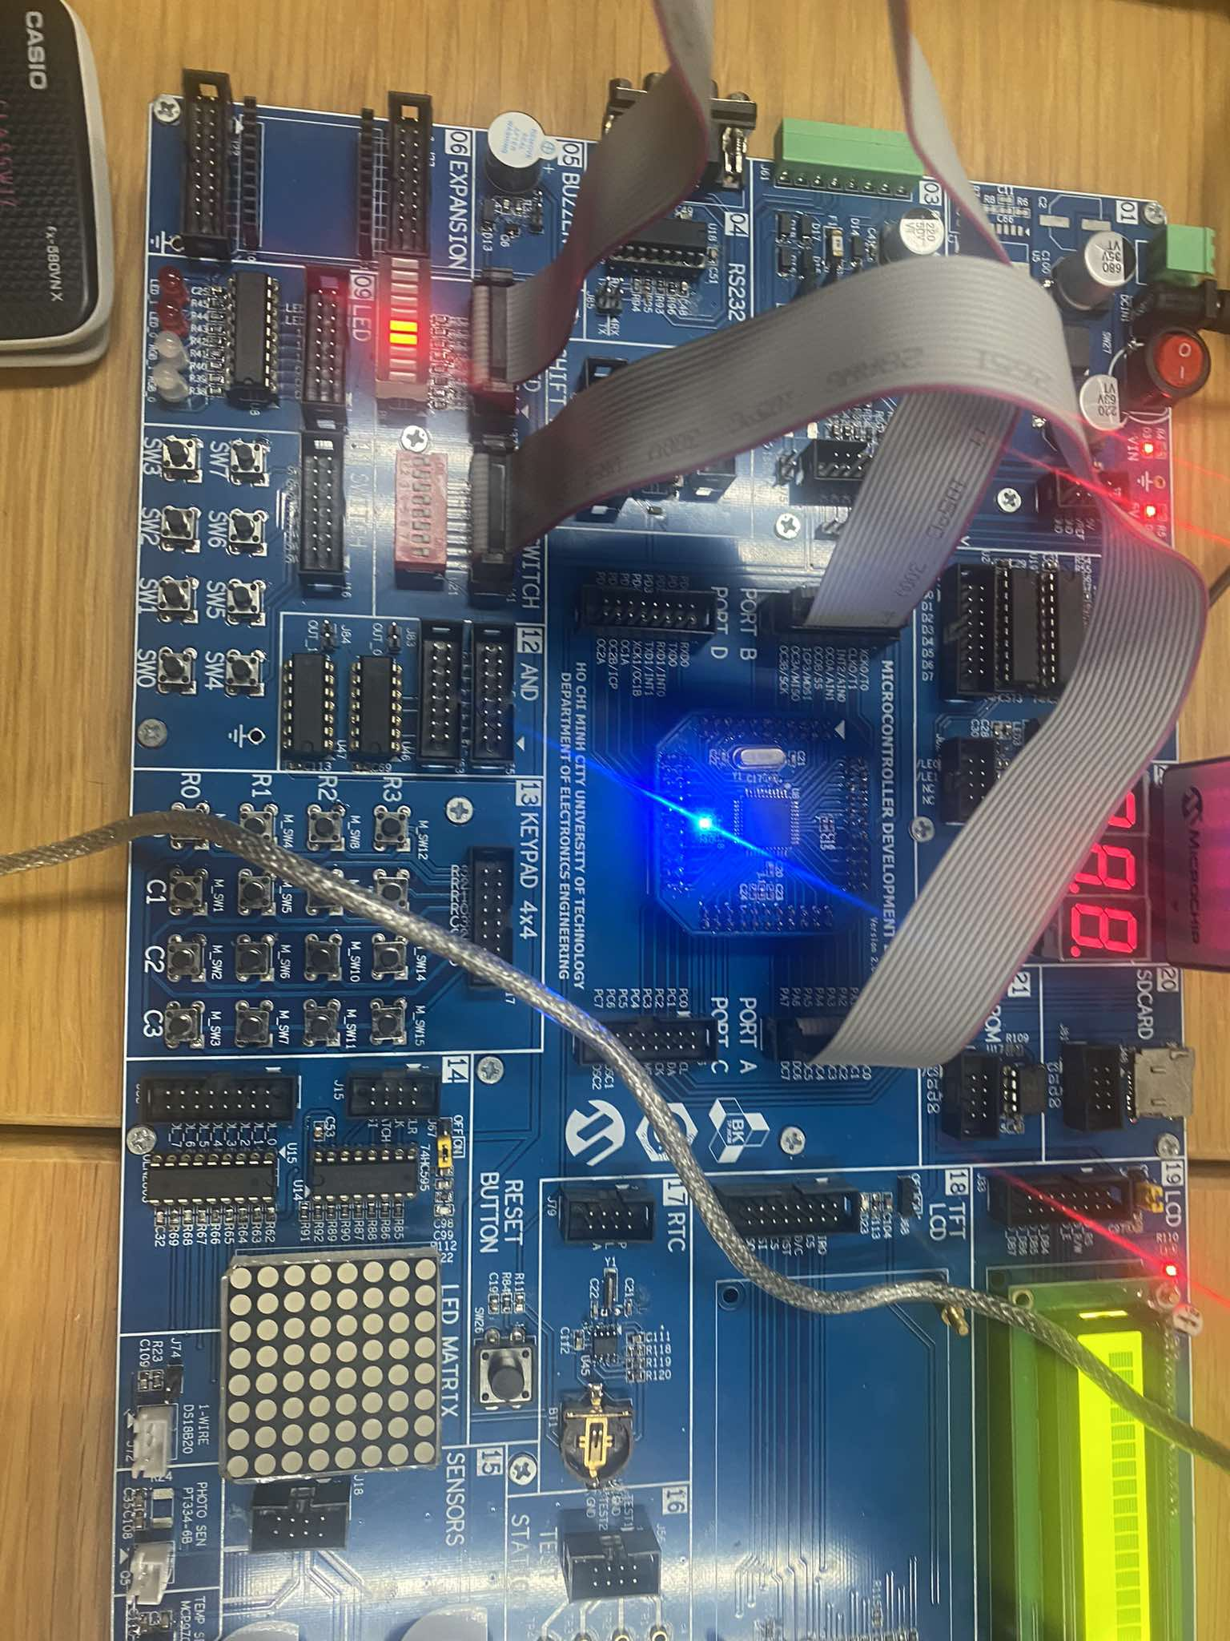
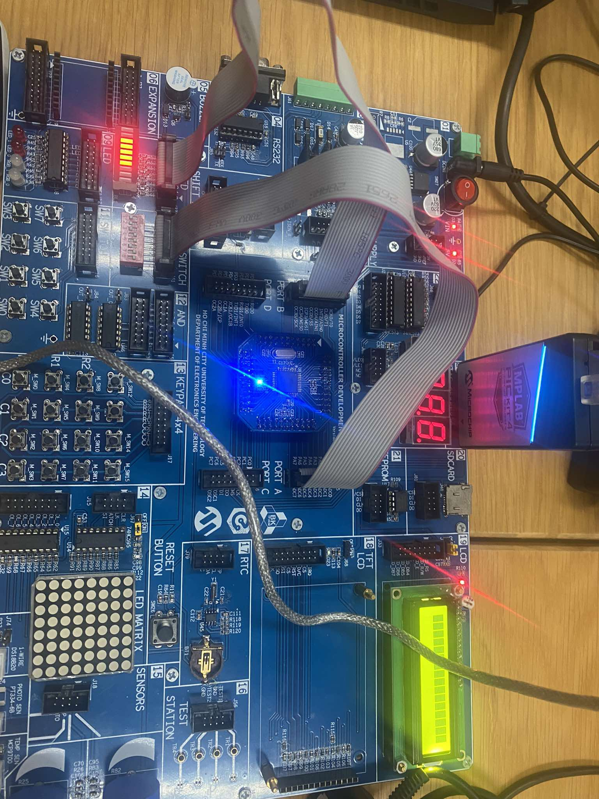

EXPERIMENT 5
- Answer the following questions:
  - When the switch is pressed/released, what is the pin value of the port?
- In order to get the kit work properly, we need to set pull-up resistor at PA0. As a result, when we press the button, PA0’s value is 0 and when we release, it will get 1. So with 1 we turn off the LED and with 0 we turn it on.
  - To make the LED light up, what logic level should the port pin output?
- LED light up so the pin PA1 need to be 1 but PA0 is 0 and vice versa.
  - Source code with comments.
START:
LDI R16, 0x02 ; Set pin 1 of PORTA as output
OUT DDRA, R16 ; Configure DDRA: pin 1 as output (0b00000010), pin 0 remains input
SBI PORTA, PA0 ; SET PULL UP REGISTER

CHECK:
IN R17, PINA ; Read from PINA (get the input value from pin 0)
ANDI R17, 0x01
CPI R17, 0x01
BREQ TURN_OFF
BRNE TURN_ON
RJMP CHECK ; Keep checking continuously
TURN_ON:
SBI PORTA, PA1
RJMP CHECK
TURN_OFF:
CBI PORTA, PA1
RJMP CHECK
